Forgot to add in prev doc

In cities like Mumbai, a map is not a static document; it is a chaotic, living environment. Footpaths are routinely excavated by the BMC or utility companies, hawkers and two-wheelers reclaim the pavement, and sidewalks frequently vanish into open drains.
To make PathClear functional in Mumbai, we must stop pretending the infrastructure is perfect and instead engineer the system to navigate the chaos. Here are the specific, localized strategies to counter these realities.
1. Countering BMC Construction (The "Perpetual Digging" Problem)
Relying strictly on users to report roadwork is too slow. You need to preempt the construction.
- The Strategy: BMC Trenching Portal Scraping. The BMC operates a "General Trench Application" and "Micro Trenches" portal where utility companies (like Mahanagar Gas, Adani Electricity, BEST) must apply for excavation NOCs.
- The Implementation: Write a Python scraper to monitor approved trenching permits in your BKC geofence. If a permit is active for "Street 5", your backend automatically injects a Construction hazard on that edge in Valhalla. The routing engine will instantly penalize this street for wheelchair profiles, long before a user ever encounters the open trench.
2. The Tapri and Two-Wheeler Problem (Dynamic Encroachments)
Illegal food stalls (tapris) and parked bikes are transient. A footpath might be clear at 9 AM but completely impassable by 1 PM.
- The Strategy: Implicit Telemetry Verification. Do not rely solely on the "1-Tap Verification" button, as users will get fatigued reporting every parked bike.
- The Implementation: Track the GPS speed and compass orientation of users traveling along a verified footpath. If three different users suddenly drop their walking speed to near-zero, or their GPS trace swerves off the footpath and onto the main road geometry, the backend instantly assumes a temporary blockage. The app automatically flags the segment as Temporarily Blocked (High Traffic) and detours subsequent wheelchair users, returning to normal only when smooth telemetry resumes.
."
3. The Broken Footpath Reality (Adaptive "Shared Street" Routing)
Standard accessible routing algorithms assume that if a street has sidewalk=no, a pedestrian cannot walk there. In India, if you block roads without sidewalks, your routing engine will fail to find a path 90% of the time.
- The Strategy: The Indian "Shared Street" Profile. You must accept that pedestrians share the road with auto-rickshaws and bikes.
- The Implementation: In your Valhalla costing logic, do not set an infinite penalty for missing sidewalks. Instead, allow routing on tertiary and residential streets but trigger a Safety HUD. Transitioning to shared road. Keep to the right to face oncoming traffic."
- / Audio Alert. When the user transitions from a paved footpath to walking on the street edge, the Voice Agent announces: "Footpath ending. Transitioning to shared road. Keep to the right to face oncoming traffic."

4. Surviving Traffic Signals (The Blind Pedestrian Challenge)
The BMC recently piloted push-button audible beepers at a few signals (like in Ghatkopar), but many older systems were disconnected due to noise complaints from residents. Blind users cannot rely on civic infrastructure to cross a Mumbai intersection safely.
- The Strategy: On-Device Vision AI (The "OKO" Approach). Do not rely on external infrastructure or internet latency.
- The Implementation: Integrate a lightweight TensorFlow Lite or YOLO Nano model* directly into the frontend app. When a blind user reaches a crossing, the voice agent prompts them to hold their phone camera forward. The local AI continuously scans for the pedestrian traffic light.
  - Red Light: The phone emits a slow, pulsating vibration.
  - Green Light: The phone emits a rapid haptic vibration and a high-pitched audio chirp, signaling it is safe to cross. Because this runs locally on the phone camera, it requires zero Wi-Fi or civic smart-city integration.

Relying on pedestrian compliance in India is a failing strategy. When a user is forced onto a shared road due to broken footpaths, the application must transition from a passive map into an active collision-avoidance system.

1. Traffic Protection on Shared Streets
When a deaf or blind user is forced onto a shared street, pre-trip consent is necessary, but active, real-time protection is mandatory.
- Acoustic Edge AI for Deaf Users: Using the smartphone’s microphone to detect approaching vehicles is highly effective if executed correctly. To counter the false-positive problem of constant Indian traffic noise, deploy an acoustic machine learning model (like YAMNet or a custom lightweight audio classifier) on the device's Edge NPU to filter for specific acoustic signatures. Train the model to trigger alerts only on the Doppler shift of a horn or engine—meaning the sound frequency is actively increasing, proving the vehicle is accelerating toward the user, rather than just idling nearby.
- Continuous Vision AI (The Virtual Cane): For blind users, running a YOLO Nano model continuously via a lanyard-mounted or chest-pocketed smartphone acts as a localized radar. To preserve battery, implement an Adaptive Framerate: the camera samples at 1fps when the GPS indicates the user is stationary, but scales to 15fps when moving. The AI scans strictly for dynamic threats (e.g., auto-rickshaws, bikes on footpaths, stray animals) and severe trip hazards (open manholes).
- Haptic Threat Directionality: When a threat is detected, the feedback must indicate direction. If an auto-rickshaw approaches from the rear-left, the phone or paired smartwatch pulses on the left side, prompting the user to step right.

The "Exploration Mode" Mitigation: The routing engine must never assign a blind user to a route with an accessibility confidence score below 0.8 unless explicitly approved by the user. If they accept an unverified route, the app enters Exploration Mode. The continuous Vision AI is dialed to maximum sensitivity.
The Telemetry Hand-Off: If the tapri blocks the entire path, the AI immediately halts the blind user, calculates the safest macro-detour, and uploads the obstacle's exact GPS coordinate to the backend. The blind user has safely bypassed the hazard, and the system is now updated for the next user.
Micro-Maneuvers vs. Macro-Detours (Path Smoothing): When the AI detects a tapri or parked bike, it does not instantly recalculate a 400-meter detour. It calculates the obstacle's bounding box. If there is 32 inches of clearance remaining, the voice agent issues a Micro-Maneuver: "Parked bike ahead. Veer slightly right for five paces

2. The "Blind User First" & Detour Fatigue Paradox
If the very first person to walk an unmapped route is a blind user, there is no historical GPS telemetry to warn them about a temporary food stall (tapri). Furthermore, constantly recalculating the entire route for every parked bike will cause severe auditory fatigue.
- The "Exploration Mode" Mitigation: The routing engine must never assign a blind user to a route with an accessibility confidence score below 0.8 unless explicitly approved by the user. If they accept an unverified route, the app enters Exploration Mode. The continuous Vision AI is dialed to maximum sensitivity.
- Micro-Maneuvers vs. Macro-Detours (Path Smoothing): When the AI detects a tapri or parked bike, it does not instantly recalculate a 400-meter detour. It calculates the obstacle's bounding box. If there is 32 inches of clearance remaining, the voice agent issues a Micro-Maneuver: "Parked bike ahead. Veer slightly right for five paces."
- The Telemetry Hand-Off: If the tapri blocks the entire path, the AI immediately halts the blind user, calculates the safest macro-detour, and uploads the obstacle's exact GPS coordinate to the backend. The blind user has safely bypassed the hazard, and the system is now updated for the next user.
3. Intersectionality: Dynamic Profiles for Multi-Disabilities
Disability is not a single toggle. A user might be deaf-blind, or use a wheelchair while legally blind. Rigid profiles (e.g., "Wheelchair Mode" OR "Blind Mode") will fail these users.
- The Constraint Matrix Architecture: Discard named profiles. Instead, the backend must evaluate users across a matrix of independent constraints: mobility_mode (manual chair, walking), vision_level (full, partial, none), and hearing_level (full, partial, none).
- Wheelchair + Blind Mitigation: The routing engine calculates a strict step-free, low-incline path, but the UI strips away all visual maps. Guidance relies entirely on clock-face audio directions and continuous Vision AI to scan for drop-offs (e.g., ensuring a wheelchair doesn't roll off an un-curbed edge).
- Deaf-Blind Mitigation: The user cannot hear audio guidance or see a high-contrast HUD. The application must connect via Bluetooth to a braille display or a smart wearable. Navigation is reduced to a learned haptic language: a continuous slow pulse means "path clear," a sharp double-tap means "step-free turn," and an erratic vibration indicates an immediate stop.

Navigating a chaotic urban environment like Mumbai exposes the limitations of basic AI. If a blind user walks into a crowded space like Dadar Market, a standard YOLO object-detection model will instantly detect 50 people, carts, and stray animals per frame. If the app attempts to read out these bounding boxes ("Person at 12 o'clock, person at 2 o'clock"), it will cause immediate sensory overload and paralyze the user.

1. The Busy Market Paradox (Preventing AI Overload)
When crowd density spikes, the AI must change its operational paradigm.
- Free-Space Segmentation (The "Anti-Object" Approach): Instead of using YOLO bounding boxes to identify individual people, the camera switches to Semantic Segmentation (e.g., DeepLabV3). The AI stops caring what the objects are and strictly calculates where the open ground plane is.
- Audio Beaconing: Rather than speaking to the user, the app emits a continuous, low-frequency "spatial audio tone" or haptic pulse that steers the user toward the largest pocket of open space, guiding them smoothly through the crowd like a fluid.
- Pedestrian Platooning: In dense traffic, blind pedestrians often cross safely by waiting for a sighted group and walking alongside them. The AI can detect the aggregate flow of a crowd and issue a prompt: "Crowd moving forward. Align with the group and match pace."
- Temporal Routing Penalties: The safest way to navigate a chaotic market is to avoid it. Valhalla can ingest OpenStreetMap opening_hours tags. During peak market hours (e.g., 5 PM – 9 PM), the routing engine severely penalizes market edges, calculating a slightly longer but much quieter parallel residential street for blind and neurodivergent users.
2. Crossing Chaotic Indian Roads
Indian intersections frequently lack audible pedestrian beepers, and vehicles routinely ignore zebra crossings.
- Optical Flow Time-to-Collision (TTC) for Blind Users: Identifying a car is not enough; the AI must calculate intent. By tracking the pixel velocity (Optical Flow) of approaching vehicles, the Edge AI calculates the Time-to-Collision. If the TTC across all lanes exceeds the user's crossing duration, the phone emits a rapid haptic chirp indicating it is safe to proceed.
- Rear-Blindspot HUD for Deaf Users: When a deaf user steps onto a crossing, they cannot hear a vehicle taking a sharp left turn directly behind them. The app can activate the smartphone's rear camera while the user looks at the screen, flashing a massive red warning if a vehicle approaches from their blind spot.
- Bilateral Curb-Cut Verification for Wheelchairs: A wheelchair user cannot simply step onto a road. The routing engine must strictly enforce that both the origin sidewalk and the destination sidewalk have verified flush curbs. If only one side has a ramp, the user will be stranded in live traffic.
Monsoon Waterlogging & Open Drains: Flooded Indian streets hide open manholes and sudden curb drops, creating lethal traps for blind and wheelchair users.
- Mitigation: Integrate local civic flood-sensor APIs or monsoon crowdsourcing data. When severe waterlogging is reported, the routing engine enforces an absolute "No-Go" parameter on those edges, overriding normal routing entirely to keep users on high ground.
The "Safe Haven" Protocol: Finding an accessible restroom or a safe place to rest is a massive anxiety trigger.
- Mitigation: Enrich the PostGIS database with "Safe Havens"—verified accessible POIs(point of interests) like modern malls, Metro stations, or luxury hotels. If a user becomes disoriented or fatigued, a single button press instantly pauses their current route and navigates them to the nearest guaranteed safe indoor environment. This is useful if user is travelling for long dist. Or time.
Walking is rarely the only mode of transport in a massive urban center like Mumbai. Disabled users must stitch together pedestrian paths, auto-rickshaws, the Metro, and BEST buses to complete a journey. Standard navigation apps assume seamless transfers between these modes, which routinely strands vulnerable users when a single piece of infrastructure breaks down.
To bridge the multi-modal gap safely, the routing architecture must mathematically model the physical barriers inside transit hubs and treat vehicles as dynamic accessibility nodes.
1. From Standard GTFS to GTFS-Pathways
Standard General Transit Feed Specification (GTFS) data is inadequate for accessibility because it only tracks vehicle schedules and coordinate stops; it cannot tell a wheelchair user how to physically get from the street to the train.
- The Mitigation: PathClear must implement the GTFS-Pathways extension. This data structure maps the exact internal 3D geometry of complex transit hubs. It mathematically models the pathway from the street entrance to the fare gates, through the concourse, and down to the boarding platform. The routing engine can then filter routes based on internal station barriers, ensuring the user is never directed to a platform accessible only by stairs.
Gtfs pathways meaning – 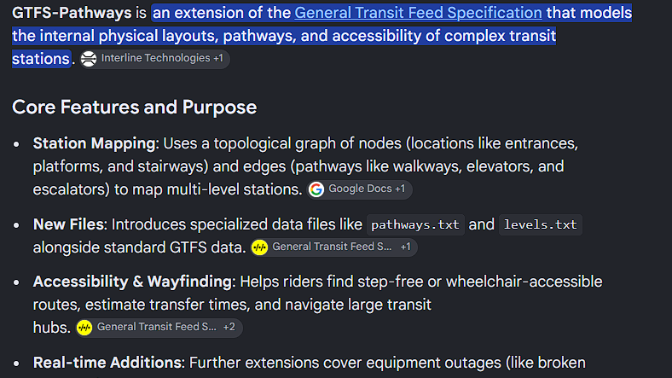
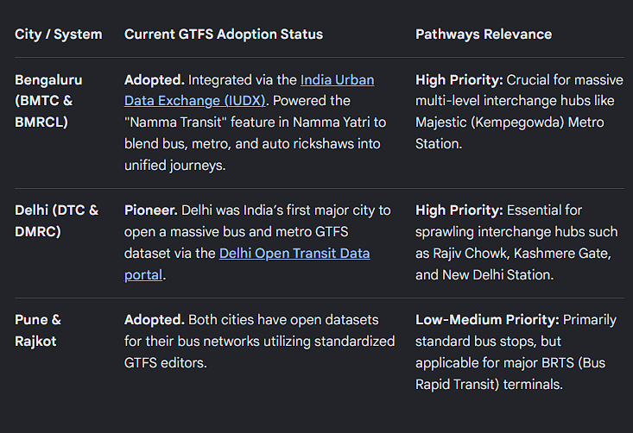
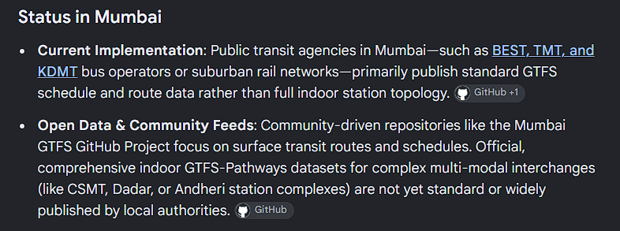

2. Live Elevator Telemetry & Dynamic Node Severing
Modern infrastructure like Mumbai Metro Line 3 is being built with extra-wide wheelchair flap gates and accessible elevators, but these mechanical systems frequently go offline.
- The Mitigation: PathClear must treat a broken station elevator exactly like an open trench on the street. If a real-time GTFS Service Alert or crowdsourced user report flags an elevator outage, the Valhalla multimodal engine must instantly sever that specific vertical accessibility node in the graph. The system immediately recalculates the journey, dynamically rerouting wheelchair users to the next fully accessible station or recommending a low-floor bus alternative before they ever board the train.
4. The Indoor "Sensory Hand-Off"
When a disabled user transitions from a chaotic street into an enclosed transit hub, their environmental threats change entirely, and the navigation system must adapt its sensory output.
- For Blind Users: The continuous Vision AI transitions from its "street mode" (scanning for approaching vehicles and parked bikes) into "station mode." It begins scanning for structural navigation anchors, guiding the user to the physical tactile paths integrated into the station floors and aligning them exactly with the platform screen doors.
- For Deaf & Hard-of-Hearing Users: Transit hubs rely heavily on audio intercoms for critical updates (e.g., "The train on Platform 1 has been changed to Platform 2"). The PathClear visual HUD syncs with live transit service alerts to push these auditory announcements as high-contrast, flashing visual banners on the user's screen, ensuring they are not left behind during sudden schedule changes.
- The Safe Haven Fallback: Navigating busy terminals can induce severe sensory overload. The system should map indoor "Safe Havens"—like quiet waiting rooms or verified accessible restrooms. A single tap allows the user to pause their active multi-modal journey and be routed immediately to the nearest safe zone to regroup.
Chartr and its Relationship to GTFS
Chartr is an Indian mobility technology platform (originally incubated at IIT Delhi) that is heavily responsible for digitizing Indian transit. They published India's first open GTFS (General Transit Feed Specification) dataset for city buses, starting in Delhi.
It operates a dual ecosystem:
- For Transit Agencies: Chartr provides a GTFS Editor tool that allows municipal agencies (like DTC or PMPML) to map their routes, stops, and schedules visually, instantly generating standardized GTFS feeds without requiring developers to write complex CSV files.
- For Passengers: The Chartr mobile app sits on top of this GTFS data, merging it with live GPS bus tracking (AVLS) and automated ticketing (AFCS). This allows users to plan multi-modal journeys, track live bus ETAs, and buy digital tickets via ONDC networks all within a single interface.

- 4. Advanced Tech Bootstrapping (Beyond Mapathons)
- Manual data collection via college mapathons is a great community builder, but it cannot scale to cover all of Mumbai.
Aerial + Street View Fusion (Machine Learning): Build a pipeline that cross-references high-resolution satellite imagery with street-level photos. A Semantic Segmentation model (like DeepLabV3) can scan satellite data to instantly map where sidewalks theoretically exist, while the backend pulls corresponding street-level images to let the Vision AI classify the pavement condition automatically.
B2B Fleet Dashcam Integration: Partner with hyper-local delivery fleets (Swiggy, Zomato, Zepto). Equip a pilot group of riders with cheap smartphone dashcams. Run an Edge AI perception node on the video feeds to continuously scan and evaluate the structural integrity of footpaths and curb cuts as the riders navigate the city.Project Sidewalk (Virtual Gamification): Deploy a web-based crowdsourcing tool modeled after Project Sidewalk. This allows volunteers to log in from home, virtually walk through Mumbai using Google Street View or Mapillary, and manually label broken footpaths, missing tactile paving, and ramps using a simple point-and-click interface.

